Ideation Phase
Brainstorm & Idea Prioritization Template

Date | 31 January 2025
Team ID | 6ab3db806603573ccfb383f7
Project Name | AI FAQ Assistant
Maximum Marks | 4 Marks

AI FAQ ASSISTANT
The AI FAQ Assistant project is designed to provide users with quick and intelligent answers to frequently asked questions along with real-time information. The system combines an AI-powered FAQ assistant with a to make information access simple, fast, and user-friendly.
The project allows users to ask questions in natural language and receive relevant answers from the FAQ knowledge base. It also provides weather details such as temperature, weather conditions, humidity, and other available information based on the selected location.
The main purpose of this project is to reduce the time required to search for common information and provide useful responses through a simple interface. By integrating AI capabilities with a , the system demonstrates how modern APIs and intelligent assistants can be combined to create a practical and interactive application.
Step-1: Team Gathering, Collaboration and Select the Problem Statement


Step-2: Brainstorm, Idea Listing and Grouping
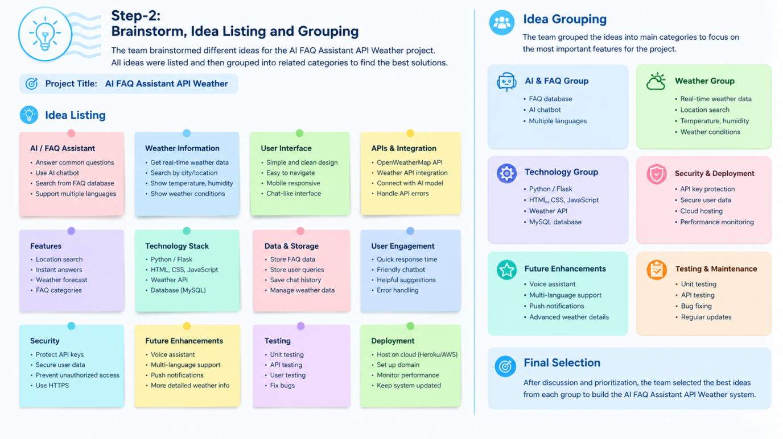

Step-3: Idea Prioritization
